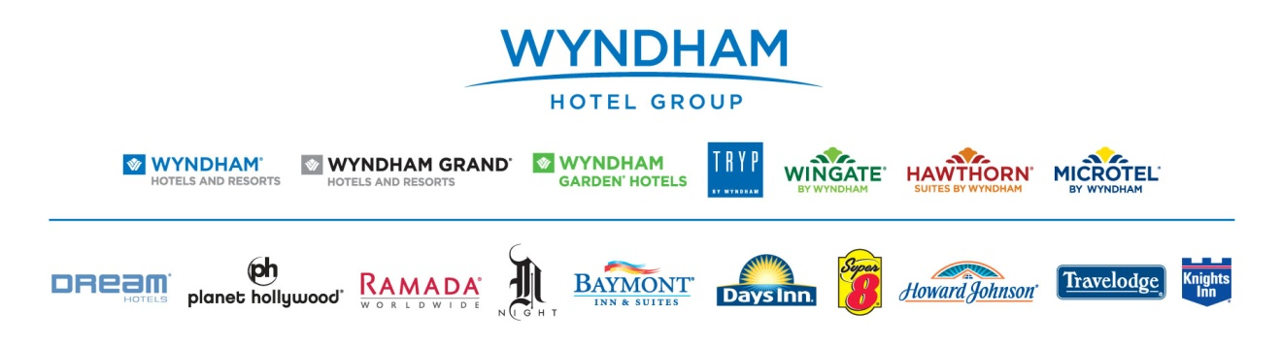
Hotel Discount Offer
The College now is now a member of Wyndham Hotel Group Member Benefit Program through E & I Cooperative. As an associate of College of the Holy Cross and a member of E and I Cooperative Purchasing you will receive up to 20% off the “Best Available Rate” at participating locations when you travel. Book online by clicking link or call and give agent your discount ID number 1000007780 and your institution’s affiliate ID number 001030 at time of booking to receive discount.
http://www.wyndhamhotelgroup.com/?corporate_id=1000007780&affilid=001030

Whether you are looking for an upscale hotel, an all-inclusive resort or something more cost-effective, we have the right hotel for you… and at the right price. So start saving now. Call our special member benefits hotline 1-800-525-5501 and reserve your room today at one of these fine hotels:

Days Inn; Howard Johnson; Knights Inn; Ramada; Super 8; Travelodge; Wingate by Wyndham; Wyndham Hotels & Resorts; Baymont Inn & Suites; Microtel Inns & Suites by Windham; Hawthorn Suites by Wyndham; Dream Hotels; Night Hotels; TRYP by Windham

©2014 Wyndham Hotel Group, LLC. All rights reserved. All hotels are either franchised by the company, or owned, and/or managed by Wyndham Hotel Management, Inc., one of its affiliates, or through a joint-venture partner.

“Best Available Rate” is defined as the best, non-qualified, unrestricted, publicly available rate on the brand sites for the hotel, date and accommodations requested. The discount for some properties may be less than 20% off Best Available Rate. Certain restrictions may apply. To redeem this offer, click our URL link on Organization’s website or call the phone number above and give ID at the time of reservation. Offer not valid if hotel is called directly, caller must use toll free numbers listed above. Advanced reservations are required. Offer is subject to availability at participating locations and some blackout dates may apply. Offer cannot be combined with any other discounts, offers, group rates, or special promotions. Discounted rates vary by location and time of year. Offer is void where prohibited by law and has no cash value. Planet Hollywood is not a current participant in the member benefit program.

