Employees can view their most current accrual balances through any of the Kronos time clocks located throughout the campus.
- Select “More” (press the blue button next to “more”)
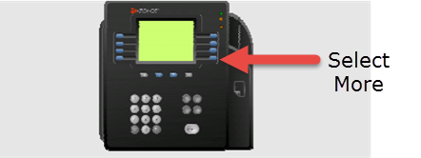

- Select “View Accruals” (press the blue button next to “view accruals”)
* location of this button may differ based on the clock used

- Slide your ID badge through the clock (same as badging in/out)

- Accruals will display on the clock

- Scroll through the display page by using the blue up/down arrows located just below the display screen.

