Enrollment Instructions

During your enrollment appointment, log in to STAR from any computer.
Note: We recommend an Ethernet cable as a backup to wireless.

- Click Student Center, then select the Enrollment Backpack link which is located beneath the grid labeled “This Week’s Schedule.”

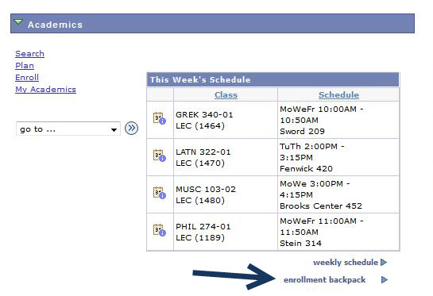

- Select the appropriate term and then

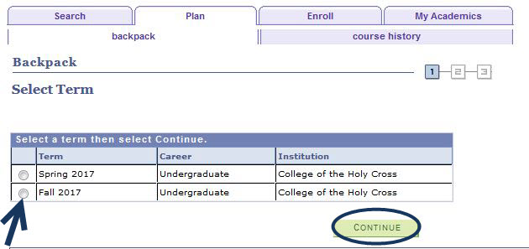

- If you have previously added courses to your backpack, you should see a listing of these courses here. Select the courses in which you want to enroll and then click the enroll button. You should select no more than four courses at a time.

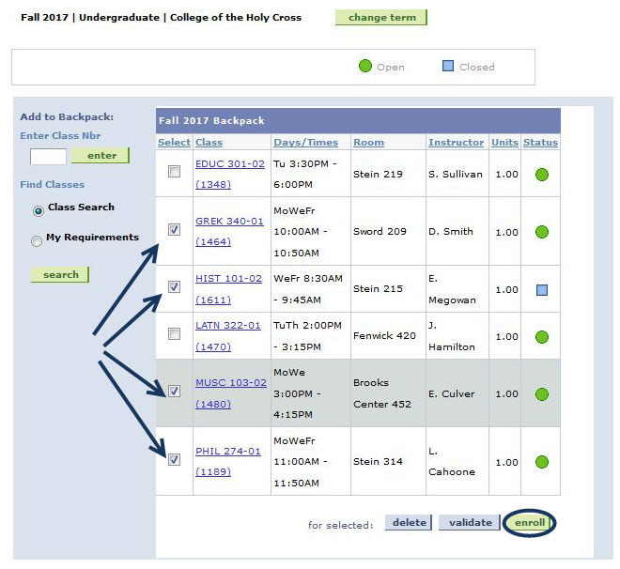

- Confirm courses and click on the Finish Enrolling button.

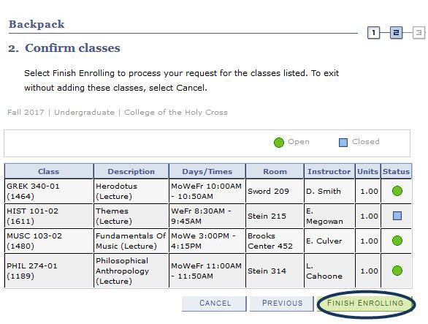

Note: This process may take several minutes to complete. If you are presented with a spinning wheel and a blank screen, please be patient and let the process finish. Clicking the back button will delay your enrollment process.
- View the results and check for messages. A green check indicates that you have successfully enrolled in the class, a red X indicates that you have not been able to enroll in the class.
If you have successfully enrolled in four classes, your enrollment is complete. You can view your complete schedule by clicking the My Class Schedule button. If you have not completed your enrollment in four classes, click the link Add Another Class to return to your backpack and select one of your alternate course choices for enrollment. If you do not have any more alternates in your backpack you can use the search button on the backpack page to search for other classes.

