COLLEGE OF THE HOLY CROSS
APPLICATION FOR ATHLETIC SEASONAL EMPLOYMENT

Name |  |  |  |  |  |  |  |  |  |  |  |  |  |  |  |  |  |  |  |  |  |  | Date
 |  |  | First |  |  |  |  | Middle Init |  |  | Last
Permanent Address |  |  |  |  |  |  |  |  |  |  |  |  |  |  |  |  |  |  |  |  |  |  | Position Desired
 |  |  |  |  |  | Street |  |  |  |  |  | City |  |  |  | State |  |  |  | Zip
Present Address |  |  |  |  |  |  |  |  |  |  |  |  |  |  |  |  |  |  |  |  |  |  | Phone No.
 |  |  |  |  |  | Street |  |  |  |  |  |  | City |  |  |  | State |  |  | Zip
Email
Member of U.S. Military Reserves or State Militia? |  |  |  |  |  |  |  |  |  |  |  |  |  | Yes No |  |  |  |  | Branch
Have you ever worked for Holy Cross before? |  |  |  |  |  |  | Yes No |  |  |  | Where? |  |  |  |  |  |  |  | When? |  |  |  |  |  |  | Person to be notified in case of emergency
 |  |  |  |  |  |  |  |  |  |  |  |  |  |  |  |  |  |  |  |  |  |  |  |  |  | Name
Have you any relatives working or studying at Holy Cross? |  |  |  |  |  |  |  |  |  |  |  |  |  |  |  | Yes No
 |  |  |  |  |  |  |  |  |  |  |  |  |  |  |  |  |  |  |  |  |  |  |  |  |  | Address
 |  |  |  | Name |  |  |  |  |  |  |  |  |  |  |  |  |  | Dept.
 |  |  |  |  |  |  |  |  |  |  |  |  |  |  |  |  |  |  |  |  |  |  |  |  |  | Phone No. |  |  |  | Relationship

 |  |  |  |  |  | Major Subject |  |  | Dates and Degrees
Education
High School
College
Business School or Other
Special Training or Skills
Employment: List most recent employment first.
Include military service assignments and any verifiable work performed on a volunteer basis. Exclude volunteer organizations’ names that indicate race, color, religion, sex, age, disability, national origin/ancestry, or sexual orientation.
 |  | Dates of Employment | Reason for Leaving
Firm: | Position: | From:
Address: | Salary:  Supervisor: | To:
Firm: | Position | From:
Address: | Salary:  Supervisor: | To:
Firm: | Position | From:
Address: | Salary:  Supervisor: | To:
Personal References
Give names and addresses of three references who are not related to you and are not previous employers, such as family physicians, landlord, etc.
 | Address
Name | Street | City | State | Occupation

Applicant’s Signature:

The College of the Holy Cross is an Equal Opportunity, Affirmative Action, Title IX Employer. The College is committed to a policy of non-discrimination and hereby reaffirms its commitment to that policy. In hiring and employment, the College policies, procedures and practices prohibit discrimination based upon race, color, religion, sex age, disability, veteran status, national origin/ancestry, sexual orientation or any other legally protected status.

Athletic Seasonal Employment
Athletics Seasonal Employment – Chart of Position Numbers

Applicant Name: _____________________________________

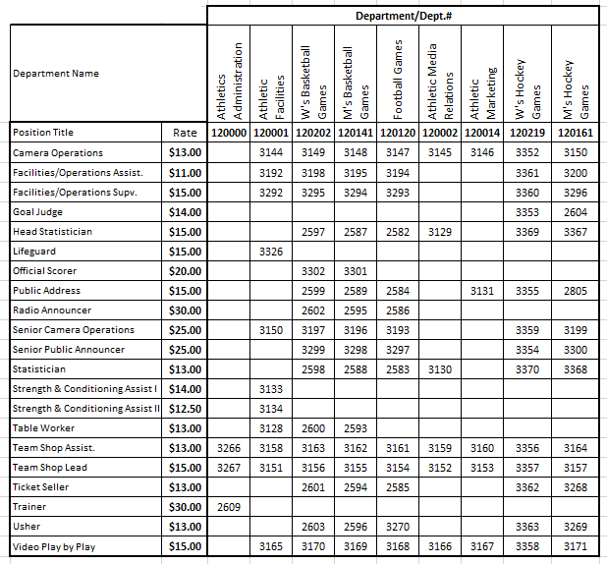
Payroll Add Notice-To be completed by Athletics after the employee is hired: Using the chart above for reference, complete one row in the chart below for each position the employee will be working.
Department No. | Position Name | Position No. | Pay Rate

Documentation Required: W-4 Form I-9 Documents Background Check
Supervisor’s Signature |  |  | Date
To be completed by Human Resources:
Effective Date: |  |  |  |  | Employee ID: |  |  | Date Processed:
Remarks:
Approved By (Signature) :

