Crusader Internship Fund Application: Submit Employment Details

Please complete the following details about your internship. Completing this form is not a guarantee for funding, this form simply allows the CCD and your employer to verify your internship details. You will be notified of your application status and possible funding via email within about 5 business days. Please note funding is limited and as summer approaches your application may be put on hold until a determination can be made.

From your Handshake account, select the Career Center Tab-> Experiences->Request An Experience

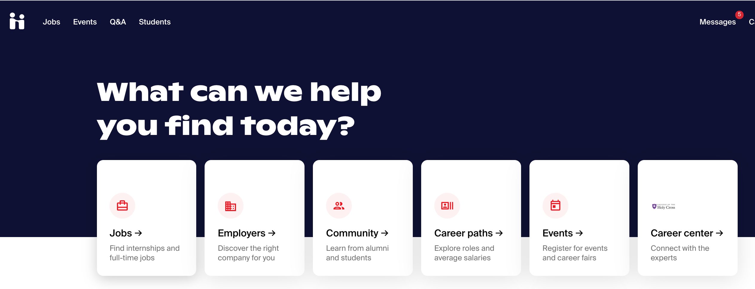

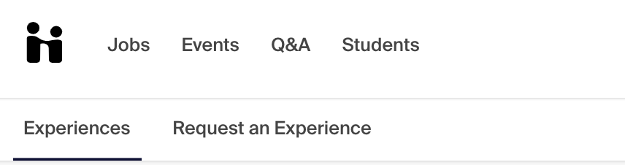

Select “Crusader Internship Fund Application Summer 2021
from the Experience Type drop down
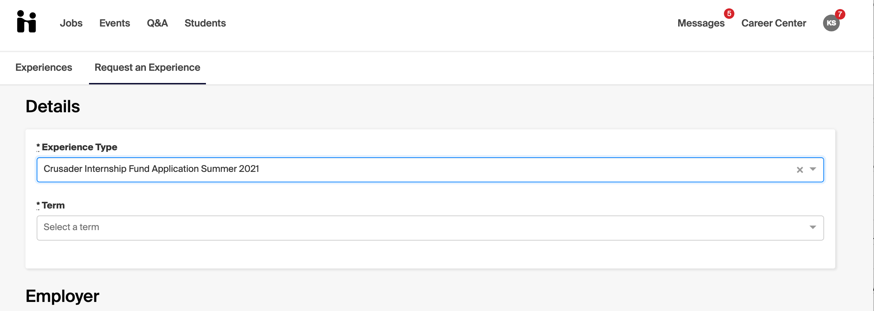

.

Complete all of the following fields in the web form on screen:

Details:

Experience Type: Crusader Internship Fund Application- Summer 2021

Term: Summer 2021

Employer:

Employer: Name of Employer

Location: City and State where internship is located

Industry: Please list industry (ex, non-profit, healthcare, etc.)

Employer Phone Number: Add if you have this information

Employer Email Address: Add your supervisor’s email address if you have it. If not, please add your HR contact’s email.

Job

Job: Enter your title (ex, Summer Intern, Summer Analyst, Marketing Intern)

Department: Add if you have this information (ex, Marketing, Accounting, Operations)

Date: start and end dates for internship

Job Type: Internship

Employment Type: Seasonal

Salary: leave blank

Offer Date: leave blank, unless you recall the date

Offer Accepted: yes or undecided

Add experience to profile: click box

Approvers

Employer Email Address: Add your supervisor’s email address if you have it. If not, please add your HR contact’s email (yes, this is the same as the above Employer Email address field, and you must enter again)

General

Please describe what you will be doing at your internship (you may copy and paste the job description here) and articulate how this internship aligns with your academic, personal and/or career goals. This should be a few sentences about the role. We are particularly interested in how the role aligns with your goals.

As part of your application, we ask that you select 2-3 of the following Career Competencies that you would like to develop through this internship experience. These will be addressed again at your midpoint and final self-evaluation where you will assess progress made. Your supervisor will also be evaluating you on all eight Career Competencies on the final employer evaluation. For more information, reference our Career Competencies Guide.

Please describe why the Career Competencies that you selected are important to you and how the internship will help you to develop these further. Use your selected Career Competencies to indicate your goals/learning objectives for your internship.

Please select the industry that best fits your internship employer. Select Other if you do not see the industry listed. If the industry is not clear, please look at the company website or email the Center for Career Development.

Is your internship at a for-profit or non-profit organization? Typical non-profit industries are education, fundraising, community organizing, government and social services. For-profit companies operate with the goal of making money and typically serve customers by selling a product or service.

Where will this internship be conducted? Please indicate the PRIMARY location where you will be conducting your internship work.

The Crusader Internship Fund offers a part time (200- 250 hours) and full time (250- 300 hours) internship option. Funding is not available for internships under 200 hours and additional funding is not available for hours worked in excess of 300 hours. Please indicate the total number of hours that you will be working during your internship. Your employer will be asked to verify this information as part of the approval process.

Have you previously received a stipend through the Crusader Internship Fund? Students are only eligible to receive funding once during their time at Holy Cross.

What is your expected month and year of graduation? Only matriculating Sophomores and Juniors are eligible to apply for funding.

What is your Holy Cross major(s)? Enter one or multiple majors

Please enter your Holy Cross ID This will be used to issue stipend checks and check financial need.

Will you need to relocate for the internship? Typically, relocation awards will be considered if your internship is more than 60 miles from your home.

How did you find this internship? Please let us know how you found this internship so that we can better provide resources to students.

Finally, please complete all acknowledgements so that the CCD can process your application.

Please click here if you consent to the Financial Aid Office determining your financial need (Yes, No option)
Please click here that you understand you will receive Experiential Learning Partial Credit (Yes option only)

Then, click the Green Request Experience Button

