Introduction
My College Emergency Notify is a self-service application that allows Holy Cross employees the ability to maintain the contact information the Connect Ed system will use to notify the College community in the event of an urgent matter on campus. This information is only for use by the emergency notification system and Human Resources.

My Emergency Notifications
To add/update your information on the My College Emergency Notify page, you need your Holy Cross network Username & Passphrase.
Navigation: Holycross.edu>Faculty & Staff> Human Resources (HR) – Self Service
Enter in your network Username and Passphrase>Enter or click Log In
Navigation: Main Menu>My Self Service>Personal Information>My College Emergency Notify
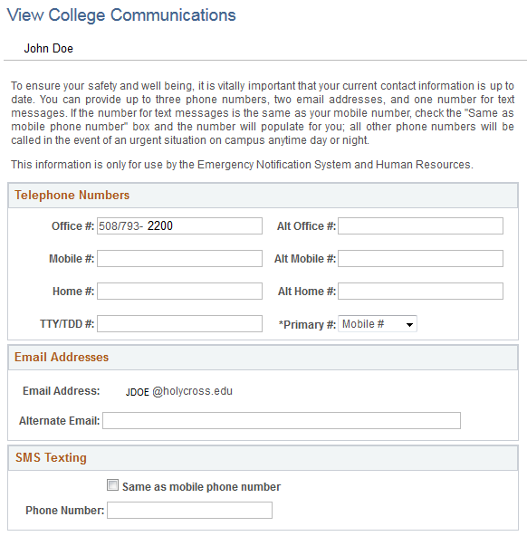
- Enter at least one phone number (office phone will default initially).
- You can enter an Alternate Email (i.e. personal email).
- Select your Primary #.
- For a text message sent to the Mobile number provided simply check the check box and that mobile number will appear.
- Click the Save Information button.

